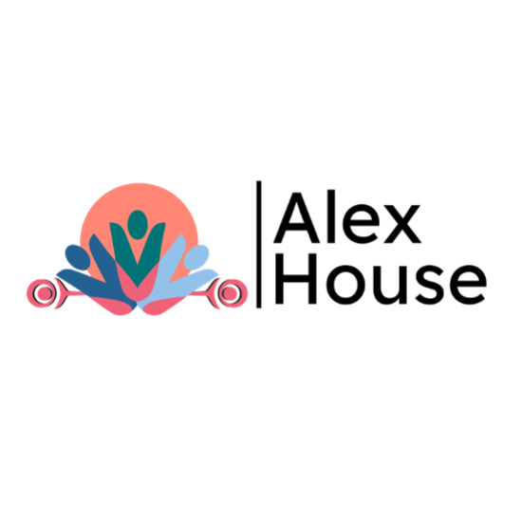

**MEMBERSHIP**

▢ Individual ▢ Family ▢ Youth ▢ Senior ▢ Life

NAME _____________________________________________________________________________________________________________

ADDRESS _____________________________________ CITY ___________________________ POSTAL CODE _________________________

PHONE ___________________________________________________ CELL ____________________________________________________

EMAIL _____________________________________________________________________________________________________________

DATE ___________________________________ SIGNATURE ________________________________________________________________

ARE YOU INTERESTED IN VOLUNTEERING? ▢ YES ▢ NO

Please accept my donation of: ▢ $500 ▢ $250 ▢ $100 ▢ $50 ▢ $25 ▢ Other _______

*Tax receipts are issued on donation of $25 or more*

▢ I would like to be an ANHBC member – Please add me to the ANHBC mailing list

▢ Please DO NOT send me information about fundraising activities & appeals

▢ DO NOT publish my name in the Barnacle or on the website

*See reverse for more information about what membership to Alex House and ANHBC includes.*

Association of Neighbourhood Houses of BC (ANHBC) is an umbrella organization of eight Neighbourhood Houses and two outdoor camps including Alexandra, Cedar Cottage, Frog Hollow, Gordon, Kitsilano, Mount Pleasant, Sasamat Outdoor Centre and South Vancouver Neighbourhood Houses. At the forefront of community development, ANHBC bridges community programs with individuals and families of all ages, abilities and nationalities in more than 20 neighbourhoods across the Lower Mainland and BC. We provide innovative and inclusive programs that engage people to live healthy, full lives and create vibrant neighbourhoods.

*PRIVACY STATEMENT: We collect personal information in order to maintain contact with you, invite you to Alex House & ANH General Meetings and to provide you with information about programs, services and events. We do not share your personal information with any external individual or group without your written permission.*



Receipt # ______________